 

**SEFA GENERAL INSTRUCTIONS**

All Federal awards received in the form of cash, must be reported on SEFA.

Federal awards are defined by 2 CFR Section 200.38 as: “Federal financial assistance and Federal cost-reimbursement contracts that non-Federal entities receive directly from Federal awarding agencies or indirectly from pass-through entities.”

Federal financial assistance means assistance that Non-Federal entities receive or administer in the form of grants, loans, loan guarantees, property (including donated surplus property), cooperative agreements, interest subsidies, insurance, food commodities, direct appropriations, and other assistance, but does not include amounts received as reimbursement for services rendered to individuals.

These awards may be received directly from the Federal grantor or as a pass-through from another state department or local governmental unit.

All Federal programs should be individually identified, including those completed or terminated during the audit period.

Include on this schedule any Federal funds received by your department that are deposited or transferred to the Capital Projects Fund.

A LINK TO THE TRAINING PPT IS ATTACHED AT THE BOTTOM OF THIS DOCUMENT FOR YOUR REFERENCE

**SEFA 01**

**CERTIFICATION**

Answer each question on the SEFA 01-Certification Form.

**Please add your Department's 3-digit number in Column D, "Applicable Department" for each question you answer Yes.**

**Question 1 - We DID NOT RECEIVE Federal Award funding. During the period referred to above, we did not receive or otherwise participate in any federal cash or non-cash awards or programs.**

**Question 2 - We DID RECEIVE Federal Award funding. During the period referred to above, we did receive or otherwise participate in any federal cash or non-cash awards or programs.**

If Questions 1 is "YES" for no Federal funds received and Question 2 is "NO" for Federal funds received, your SEFA Certification is complete, and you can submit your SEFA Report to your approver. You do this by selecting the green button in the bottom right-hand corner.

**An email will be sent to your Approver.

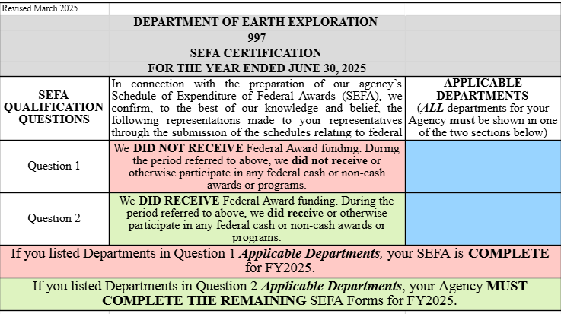

**SEFA 02**

**GRANTS & PROGRAMS**

**All Federal programs should be individually identified, including those completed or terminated during the audit period. submission.**

**All Agency supporting reconciling documents, used by the Agency to reconcile Workiva to eMARS, must be attached to the SEFA 02 worksheet, in Workiva.**

**These are the reports used by FAC to AUDIT the SEFA 02 completion, submitted by the Agency.**

1. Information contained in the SEFA 02 should be reconciled to the eMARS ebi report - the 2035 Report.

***Additionally, the Agency is responsible for the ***Reconciliation*** completion, FAC is responsible for the ***AUDIT*** of the ***Reconciliation*** between the two systems. The ***Reconciliation*** for both Revenues and Expenditures are shown at the bottom of the Agency SEFA 02. The ***Reconciliation*** is prepopulated with the information entered on the worksheet.***

If additional rows need to be inserted into the ***Reconciliation***, please reach out to: Gina Shall - [ginac.shall@ky.gov](mailto:ginac.shall@ky.gov) and Carolyn Noplis - [carolyn.noplis@ky.gov](mailto:carolyn.noplis@ky.gov).

**\*\*\*ALL ENTRIES ON SEFA 02 RECONCILATION (revenue and expenditures) MUST equal ZERO – IF NOT THE SEFA 02 THE SEFA 02 WILL BE REJECTED\*\*\***

1. Column A – **FISCAL YEAR**  - this is a prefilled column – no entry necessary.
2. Column B – **DEPT** – this is a prefilled column – no entry necessary.
3. Column C – **FEDERAL PREFIX ALN \*\*\***IMPORTANT*** ‑ Agencies may receive funds without knowing the proper **ALN**, processing of these funds is permitted without an ALN. However, the responsibility for the completion of Column A (**Federal Prefix ALN**) lies with the reporting Agency. Agencies are responsible for the inclusion of the **ALN** on the SEFA 02. When reconciling the SEFA 02 with the 2035 Report from ebi, review all transactions for **proper ALN** in Column A.

**\*\*\*ALL ENTRIES ON SEFA 02 MUST INCLUDE THE ALN – IF NOT INCLUDED ON THE SEFA 02, SUBMITTED BY THE AGENCY – THE SEFA 02 WILL BE REJECTED\*\*\***

1. Column D – **FEDERAL GRANTOR PROGRAM TITLE** – Record the name of the Federal Grant Program Title for the Revenues and Expenditures.

**\*\*\*ALN INFORMATION CAN BE FOUND ON THE FOLLOWING sam.gov LINK: https://sam.gov/\*\*\***

1. Column E –  **UEI**  - UEI = Unique Entity Identifier can also be found on [**https://sam.gov/**](https://sam.gov/)**.** The UEI allows your Agency to conduct business with the Federal Government.
2. Column F – **COVID-19 AND ARRA Specific Economic Act** – **Enter:**

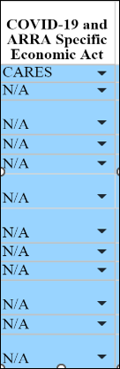 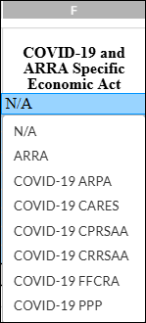

The Specific Economic Act Programs are identified separately on the SEFA. Select the applicable Specific Economic Act for your program from the drop-down list.

**YOU MUST select “N/A” if your program is not COVID-19 or ARRA funded, or the dollar amounts will not roll forward in the formulas.**

The following Acts are available from the Drop-down list:

1. N/A: Not Applicable
2. ARRA: American Recovery and Reinvestment Act
3. COVID 19- ARPA: American Rescue Plan Act
4. COVID 19- CARES: Coronavirus Aid, Relief and Economic Security Act
5. COVID 19- CPRSAA: Coronavirus Preparedness and Response Supplemental Appropriations Act
6. COVID 19- CRRSAA: Coronavirus Response and Relief Supplemental Appropriations Act
7. COVID 19- FFCRA: Families First Coronavirus Relief Act
8. COVID 19- PPP: Paycheck Protection Program and Health Care Enhancement Act
9. Column G – **COLLECTED REVENUES** - These can be one of two revenue streams: 1) Direct Federal Award and 2) Federal Pass-through Revenue. These are defined as:
   * **DIRECT FEDERAL REVENUE** – Funds received directly from the Federal government
   * **FEDERAL PASS-THROUGH REVENUE** – Funds received from another organization that were originally from the Federal government.
10. Column H – **CASH EXPENDITURES** - Federal expenditures for the period. The amounts should be reconciled to eMARS on a grant-by-grant basis. Expenditure amounts should also be reconciled to grantor financial reports.

Vendor type payments made to state departments should be shown in this column. Pass through type payments to state departments should not be shown in column H but in Column J as a pass through. Program income should not be deducted from expenditures in column H. Program income should be recorded as income in column G.

A refund of current year expenditures would be reflected in this column.

1. Column I – **RESEARCH AND DEVELOPMENT CASH** EXPENDITURES – Refers to all systematic research activities (both basic and applied) as well as development activities performed by a non-Federal entity, aiming to gain new scientific knowledge or understanding and then utilize that knowledge to produce useful materials, devices, systems, or methods, including design and development of prototypes and processes; essentially.
   * Within a SEFA report, "R&D" is considered a "cluster," meaning that various Federal programs categorized as research-oriented are grouped together under this label.
   * Unlike other clusters in SEFA which might be identified by specific program codes, R&D requires the receiving agency to manually tag expenditures as R&D when entering data into the report.
2. Column J – **CASH PASSED THROUGH *FROM* OTHER DEPARTMENTS - Federal** funds received by an organization that are then distributed to other entities, known as Subrecipients, to carry out a specific program or project.
   * The organization acts as a conduit to pass the funds on to others rather than using them directly for their own operations; this is typically reported as "pass-through payments" to Subrecipients on the SEFA**.**
   * Paid to grantor should consist of amounts paid to grantor departments during the fiscal year; for example, unexpended monies of terminated grants. Usually, this will consist of monies returned directly to a Federal grantor. An exception to this would be when you return monies to a department from which you initially received pass‑through monies. Report the returning monies to a pass-through department as a deduction in Column K.
3. Column K – **CASH PASSED THROUGH *TO* OTHER DEPARTMENTS** ‑ Pass throughs to other departments (including revenue redistributions) should consist of moneys distributed from the grant to other Federal grants (either to inside the department or to another state department) to fund Federal expenditures.
   * Passed through amounts between grants within the same department must agree.
   * Payments made to state departments, even if made electronically, except to state universities, would be shown in this column.
   * Report Federal monies to a state university Subrecipient as an expenditure in Column H.
   * The primary recipient agency (the state agency passing Federal funds to another state agency) should not include revenue or expense related to the pass-through on SEFA or eMARS.
   * That is the primary recipient agency would reduce its revenue by the amount transferred to the sub-recipient agency, rather than report the amount as an expenditure or transfer.
   * On SEFA 02 the primary recipient agency would show total Federal draw downs in Column G and the “pass-through” in Column J. Column G minus Column J on SEFA 02 should equal total revenues for that particular Federal catalog number in eMARS.
   * Transfers to component units (i.e. Kentucky Housing Corporation, Kentucky Infrastructure Authority) will not be considered a pass-through but an expenditure to a sub-grantee and would appear in Column H of SEFA 02.
   * These amounts would also be reported on SEFA 06.

All amounts in this column must be explained in the Notes. (See Sample SEFA 05.)

1. Column L – **PAID TO GRANTOR** ‑ A grantor for a Federal SEFA is a Federal agency or pass-through entity that provides Federal funds to a recipient. Other deductions should consist of payments of Federal moneys during the fiscal year not covered by (H), (I), or (J).
2. Column M – **NONCASH EXPENDITURES** ‑ The value of items received as Federal assistance that are not directly paid for with cash, such as donated property, equipment, food commodities, free rent, or surplus property, which must be reported on the Schedule of Expenditures of Federal Awards (SEFA) at their fair market value when received, even if they are not considered an immediate expense on the organization's financial statements; essentially, any non-monetary Federal award received by an organization needs to be included on the SEFA.  The ending balance should consist of amounts due from grantor, unearned revenue for active grants, amounts due to grantor for termi­nated grants, or zero. The ending balance must equal column D, plus E, plus F, plus G, minus H, minus I, minus J, and minus K.

Report on this schedule all Federal noncash programs which would be covered by the following definition of Federal financial assistance from 2 CFR Section 200.40:

Assistance that non-Federal entities receive or administer in the form of grants, loans, loan guarantees, property (including donated surplus property), cooperative agreements, interest subsidies, insurance, food commodities, direct appropriations, and other assistance but does not include amounts received as reimbursement for services rendered to individuals.

Examples of noncash programs reported by state departments for FY 2025 included:

* Food stamps
* Commodities
* Student loan guarantees
* Surplus property
* Intergovernmental personnel (percent or all an employee’s salary paid by a Federal agency)
* Report the amount of noncash assistance distributed (e.g., amount of food stamps or commodities distributed) or the amount used (e.g., amount of personal property placed into use) during the period in the expenditure column.
* If your department received noncash assistance from another state department, the amount your department expended should be reported as passed through from the grantor department on your schedule of noncash Federal awards. If your department passed noncash assistance to a second state department, your department should exclude the passed through amount from its program expenditures on its Schedule of Expenditures of Federal Awards – Noncash Programs (SEFA 03). The amount excluded and the department to which it was sent should be presented in a note to the schedule of noncash Federal awards.
* Explain the method or basis of valuing the Federal assistance. If the value was taken from Federal reports, identify the name and/or number of the report.
* If you are in doubt as to whether something meets the definition of Federal assistance, report it along with your noted uncertainty.
* To ensure completeness of the schedule, review the FY 2025 schedule and verify that all continued programs are reported on the FY 2025 schedule.
* For inventorial type assistance (such as food stamps and commodity foods), the amount disbursed during FY 2025 should agree to the current year disbursements disclosed in the related note. (See item #6 in the Instructions for SEFA 5 ‑ Notes to the Schedule of Expenditures of Federal Awards.)
* Disclose the basis of presentation for the noncash assistance in Note 1 of the Notes. (See Sample SEFA 5.)

1. Column N – **NONCASH EXPENDITURES** ‑ The value of items received as Federal assistance that are not directly paid for with cash, such as donated property, equipment, food commodities, free rent, or surplus property, which must be reported on the Schedule of Expenditures of Federal Awards (SEFA) at their fair market value when received, even if they are not considered an immediate expense on the organization's financial statements; essentially, any non-monetary Federal award received by an organization needs to be included on the SEFA.  The ending balance should consist of amounts due from grantor, unearned revenue for active grants, amounts due to grantor for termi­nated grants, or zero. The ending balance must equal column D, plus E, plus F, plus G, minus H, minus I, minus J, and minus K.

**SEFA 03**

**NOTES**

**NOTE 1: Basis of Accounting**

**Enter:**

1. **Basis of Accounting, if not modified cash basis**

Departments receiving cash Federal awards must disclose the basis of accounting for cash awards. Note 1 is prefilled with a statement for your Department’s Basis of Accounting.

**The SEFA is presented on the modified cash basis of accounting as recorded in eMARS.**

If your Department does not use modified cash basis of accounting, **disclose the basis used**.

**EXAMPLE: SEFA 03, Note 1**



**SEFA 03**

**NOTES (continued)**

**NOTE 2: Research and Development (R & D)**

**Enter:**

1. ALN
2. Program Title
3. The expenditures amount related to Research and Development
4. The expenditures amount not related to Research and Development
5. Total of all expenditures for each Federal Program
6. Explanation of the Determination made of the Research and Development Expenditures

All Federal programs with research and development expenditures as defined in the 2 CFR Section 200.87 should be reported. Explain how the Department determined the research and development expenditures. If the research and development expenditures are coded in eMARS, please indicate appropriate codes for each Federal program. If the research and development expenditure amounts are determined, or accounted for, outside of eMARS, please provide a detailed explanation of the process.

*\*\*The total dollar amount of all expenditures in the note must agree to SEFA 02 -Grants and Programs Form, Column J, Research and Development Cash Expenditures.\*\**

**EXAMPLE: SEFA 02 totals and SEFA 03 Note 2, R & D totals agree**

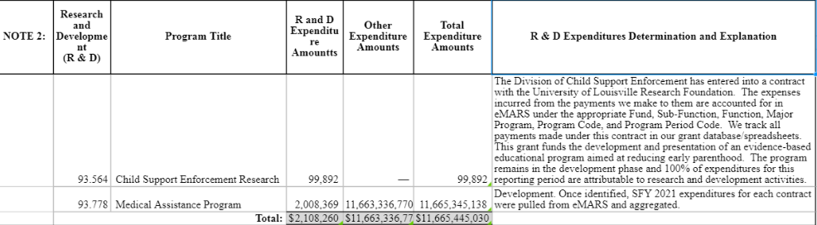

**SEFA 02 R & D Amounts**

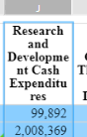

**SEFA 03**

**NOTES (continued)**

**NOTE 3: Passed Through FROM Other Departments**

**Enter:**

1. ALN
2. Program Title
3. Dollar Amount
4. Department Name and Number that passed through funds to your Department

All Cash Passed Through **FROM** Departments should be reported.

*\*\*The total dollar amount in the note must agree to SEFA 02 -Grants and Programs Form, Column K, Cash Passed Through FROM Other Departments amount.\*\**

**EXAMPLE: SEFA 02 totals and SEFA 03 Note 3 Passed Through FROM Other Departments agree**

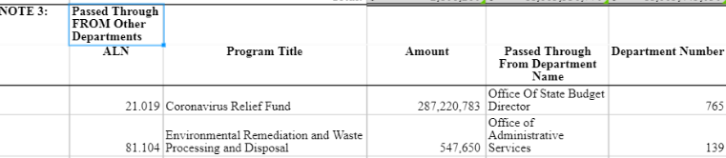

**SEFA 02 Passed Through FROM Amounts** 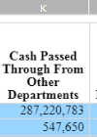

**SEFA 03**

**NOTES (continued)**

**NOTE 4: Passed Through TO Other Departments**

**Enter:**

1. **ALN**
2. **Program Title**
3. **Dollar Amount**
4. **Department name and number that your Department passed the funds to**

All Cash Passed Through TO Departments should be reported.

*\*\*The total dollar amount in the note must agree to SEFA 02 -Grants and Programs Form, Column L, Cash Passed Through TO Other Departments amount.\*\**

**EXAMPLE: SEFA 02 totals and SEFA 03 Note 4 Passed Through TO Other Departments agree**

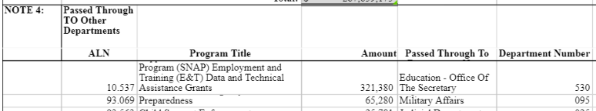

**SEFA 02 Passed Through TO Amounts** 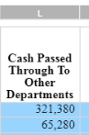

**SEFA 03**

**NOTES (continued)**

**NOTE 5: Paid to Grantor**

**Enter:**

1. ALN

2. Program Title

3. Dollar Amount

4. Description: Explanation for the funds being paid to a grantor

All amounts Paid to Grantor should be reported. Amounts should consist of amounts paid to grantor Departments during the fiscal year, including funds returned directly to a Federal grantor.

*\*\*The total dollar amount in the note must agree to SEFA 02 -Grants and Programs Form, Column M, Paid to Grantor amount.\*\**

**EXAMPLE: Paid to Grantor**

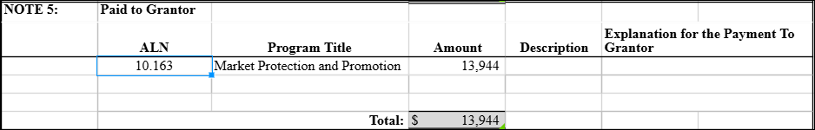

**EXAMPLE: Funds *RETURNED* to Grantor**

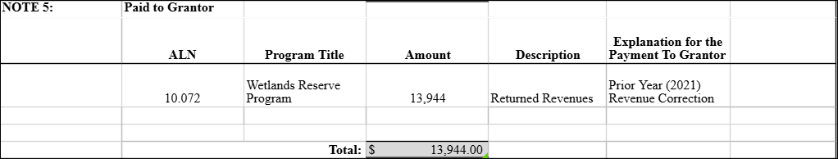

**SEFA 03**

**NOTES (continued)**

**NOTE 6: Noncash Expenditures**

**Enter:**

1. ALN
2. Type of Assistance
3. Dollar Amount
4. Method/Basis of Valuation

Explain the method or basis of valuing the Federal assistance. If the value was taken from Federal reports, identify the name and/or number of the report.

*\*\*The total dollar amount in the note must agree to SEFA 02 -Grants and Programs Forms, Column N, Noncash Expenditures.\*\**

**EXAMPLE: SEFA 02 totals and SEFA 03 Note 6, Noncash Expenditures agree.**

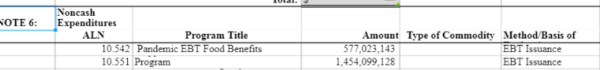

**SEFA 02 Noncash Expenditures** 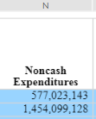

**SEFA 03**

**NOTES (continued)**

**NOTE 7: Noncompliance Items**

**Enter:**

1. ALN
2. Program Title
3. Dollar Amount
4. Description: Explanation of the noncompliance items

Noncompliance items must be detailed in the notes.

**\*\*\*\*\*\*\*\*\*\*\*\*\*\*\*\*\*\*\*\*\*\*\*\*\*\*\*\*\*\*\*\*\*\*\*\*\*\*\*\*\*\*\*\*\*\*\*\*\*\*\*\*\*\*\*\*\*\*\*\*\*\*\*\*\*\*\*\*\*\*\*\*\*\*\*\*\*\*\*\*\*\*\*\*\*\*\*\*\*\*\*\*\*\*\***

**NOTE 8: ALN's Not Previously Reported (New**)

**Enter:**

1. ALN
2. Program Title

Document any **NEW** Federal programs that your Department **will report on this fiscal year**.

**\*\*\*\*\*\*\*\*\*\*\*\*\*\*\*\*\*\*\*\*\*\*\*\*\*\*\*\*\*\*\*\*\*\*\*\*\*\*\*\*\*\*\*\*\*\*\*\*\*\*\*\*\*\*\*\*\*\*\*\*\*\*\*\*\*\*\*\*\*\*\*\*\*\*\*\*\*\*\*\*\*\*\*\*\*\*\*\*\*\*\*\*\*\*\***

**NOTE 9: ALN's No Longer Reported**

**Enter:**

1. ALN
2. Program Title

Document any Federal programs that your Department will **NO longer report on this fiscal year**.

**\*\*\*\*\*\*\*\*\*\*\*\*\*\*\*\*\*\*\*\*\*\*\*\*\*\*\*\*\*\*\*\*\*\*\*\*\*\*\*\*\*\*\*\*\*\*\*\*\*\*\*\*\*\*\*\*\*\*\*\*\*\*\*\*\*\*\*\*\*\*\*\*\*\*\*\*\*\*\*\*\*\*\*\*\*\*\*\*\*\*\*\*\*\*\***

**NOTE10: Departments Receiving CPA Audits**

**Enter:**

1. CPA Firm Name
2. Contact person
3. Telephone number
4. Email address

Document the CPA Firm Name, contact person, telephone number and email address of any CPA audits for your Department.

**\*\*\*\*\*\*\*\*\*\*\*\*\*\*\*\*\*\*\*\*\*\*\*\*\*\*\*\*\*\*\*\*\*\*\*\*\*\*\*\*\*\*\*\*\*\*\*\*\*\*\*\*\*\*\*\*\*\*\*\*\*\*\*\*\*\*\*\*\*\*\*\*\*\*\*\*\*\*\*\*\*\*\*\*\*\*\*\*\*\*\*\*\*\*\***

**NOTE 11: Loan Type Programs**

**Enter:**

1. ALN
2. Program Title
3. Dollar Amount of loans outstanding at beginning of year
4. Dollar Amount of new loans made during the fiscal year
5. Dollar Amount of loans paid in full during the fiscal year
6. Dollar Amount of loans outstanding at end of fiscal year

Document any loan type programs for your Department in the note.

**\*\*\*\*\*\*\*\*\*\*\*\*\*\*\*\*\*\*\*\*\*\*\*\*\*\*\*\*\*\*\*\*\*\*\*\*\*\*\*\*\*\*\*\*\*\*\*\*\*\*\*\*\*\*\*\*\*\*\*\*\*\*\*\*\*\*\*\*\*\*\*\*\*\*\*\*\*\*\*\*\*\*\*\*\*\*\*\*\*\*\*\*\*\*\***

**NOTE 12:** **Additional Details**

**Enter:**

1. Additional Notes

Add additional notes to disclose any condition, which could be material to, or would enhance the presentation of, your Department's SEFA.

**SEFA 04**

**SUB RECIPIENTS**

The Schedule of Sub Recipients is needed to determine whether the Subrecipient audit requirement is being met.

2 CFR Section 200.330 defines Subrecipient and contractor/vendor as follows:

Subrecipient means a non-Federal entity that expends Federal awards received from a pass-through entity to carry out a Federal program but does not include an individual that is a beneficiary of such a program.

Vendor means a dealer, distributor, merchant, or other seller providing goods or services that are required for the conduct of a Federal program. These goods and services may be for an organization's own use or for the use of beneficiaries of the Federal program.

2 CFR Section 200.330 provides characteristics indicative of Subrecipients and vendors:

A Subrecipient:

1. Determines who is eligible to receive what Federal financial assistance;
2. Has its performance measured against whether the objectives of the Federal program are met;
3. Has responsibility for programmatic decision making;
4. Has responsibility for adherence to applicable Federal program compliance requirements; and
5. Uses the Federal funds to carry out a program of the entity as compared to providing goods or services for a program of the pass-through entity.

A Contractor/Vendor:

1. Provides the goods and services within normal business operations;
2. Provides similar goods or services to many different purchasers;
3. Operates in a competitive environment;
4. Provides goods or services that are ancillary to the operation of the Federal program; and
5. Is not subject to the compliance requirements of the Federal program.
6. The Schedule of Subrecipient (SEFA 06) “amount sent” should not be greater than the “Cash Expenditures” amount shown on the department’s SEFA (SEFA 02) or noncash expenditures (SEFA 03). Please be sure to compare the Subrecipient Schedule to the Department’s SEFA 2 and SEFA 3. Please provide a note on the SEFA 06, if the amounts on the SEFA 06 and SEFA 02 are different, to explain the variances.
7. The Subrecipient’s state vendor number is critical in consolidating the information due to the numerous ways a Subrecipient may be titled. Please be certain supply this data.
8. This schedule should include ***ALL*** Subrecipients, regardless of the amount involved. The amount should only include Federal expenditures.

**SEFA 04**

**SUB RECIPIENTS (continued)**

1. This schedule should include Subrecipients, such as local governments, school or special districts, nonprofit organizations, and universities. Do not include state departments on this schedule. Money sent to or received from other state departments appears on SEFA 02 under the pass through to/from columns and on SEFA 05 under Notes 2 and 3.
2. If your accounting system does not allow for reporting Subrecipients in the requested format (Example: Multi‑funding source contracts), please contact Brittany Wise at 502-564-7753 to discuss an acceptable alternative procedure.
3. This schedule should include both cash and noncash assistance. The value of any noncash assistance should be shown in the "amount" column.

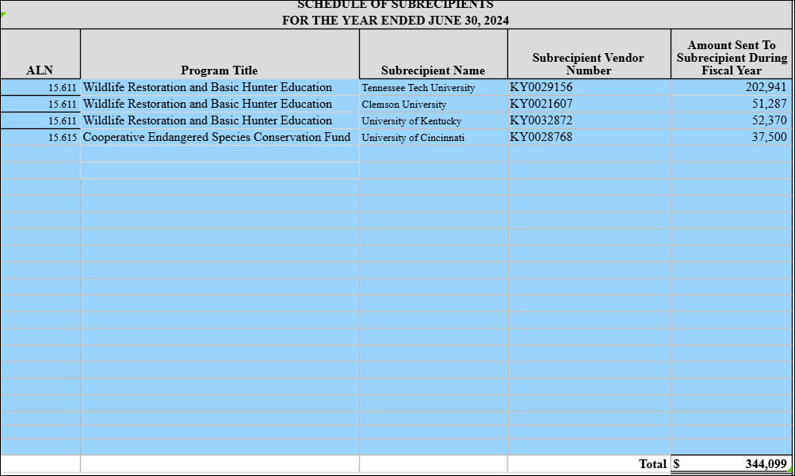 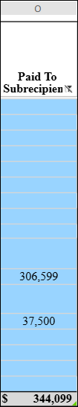

**SEFA 05**

**Certification of Having Federal Awards**

LINK TO SEFA POWERPOINT PRESENTATION:

[2025 Training SEFA Reporting 01.2025](https://kymsoffice-my.sharepoint.com/personal/carolyn_noplis_ky_gov/Documents/Desktop/SEFA%20Instruction%20Info%20-%20Used%20for%20Updated%20Materials/2025%20Training%20SEFA%20Reporting%2001.2025.pptx?web=1)